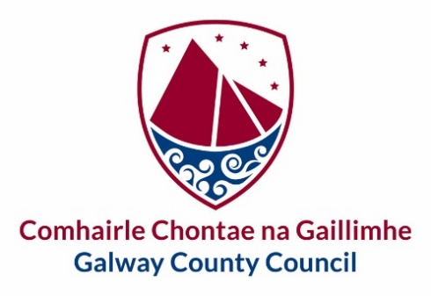

**Ballinasloe Town Team – Expressions of Interest**

Galway County Council are beginning the process of developing a Town Centre First (TCF) Plan relating to Ballinasloe Town Centre and would like to invite expressions of interest from the local community to create a dedicated TCF Town Team. A TCF Town Team is a group of local residents, businesspeople, community representatives and other stakeholders who come together to make their area a better place to live, work, study and visit. TCF Town Team members may come from diverse sectors and backgrounds. They have a unique position in the community to become ‘local experts’ on their area and to take a lead on the development of projects that can make positive long-term changes for the town.

The TCF Town Team will work closely alongside the Town Regeneration Officer and the Council’s multi-disciplinary Regeneration team. Members must work on behalf of the community as a whole and not in their own interests or in the interests of an individual or a specific group(s).

The TCF plan for Ballinasloe will focus on broad themes, identifying proposals to address these themes, for example, Built Heritage, Tourism, Arts and Culture, Local Economy, Town centre living, community facilities and amenities, to mention a few. Please review the Town Centre First Policy available at: <https://www.gov.ie/en/publication/473d3-town-centre-first-policy/>

Town Team meetings will be held in-person either monthly or every two weeks depending on the Teams workload, Team members are required to commit to attendance at these meetings and to work in positive and proactive collaboration with other team members, stakeholders, the wider community and Galway County Council.

After the closing of this call for expressions of Interest, a shortlist of applicants will be created. The Core Town Team will have a maximum of 12 members, with sub-groups created if necessary to help advance specific projects or proposals which emerge from the TCF Plan

Please register your interest by submitting the Expression of Interest Form via e-mail to [regeneration@galwaycoco.ie](mailto:regeneration@galwaycoco.ie) or by post to Urban & Rural Regeneration Team, Economic Development and Planning, Aras an Chontae, Prospect Hill, Galway H91 H6KX.

**Closing date for applications is Wednesday the 21st of August.**

|  |  |  |  |
| --- | --- | --- | --- |
| gcc logob stacked.png |  | | **Ballinasloe Town Team - Participation Forum** |
| **Tá an fhoirm seo le fáil i gcló mór chomh maith** | | This form is also available in large print | |
| **Tá míle fáilte an fhoirm seo a líonadh i nGaeilge** | | | |

|  |
| --- |
| **Expression of Interest Form** |

|  |  |
| --- | --- |
| Are you part of an existing Community/sport or other group? If yes, please give details below | Yes No |
| Name of Group/s: (as relevant) |  |
|  |
|  |
| Role of Nominee within existing group: |  |
| Please indicate your area of interest, select 1 only:  Culture & Built Heritage  Community & Sports and recreation  Economic Development & Tourism  Vacancy and Dereliction  Public spaces & streetscapes  Natural environment & Biodiversity |  |
| Please indicate why you want to be part of the Ballinasloe Town team? |  |
| Would be interested in a lead role within the Town Team,  Please select 1 role:  Chairperson  Secretary  Town Champion |  |
| Contact Telephone number for Nominee: |  |
| **Contact E-mail for Nominee:** |  |

|  |  |
| --- | --- |
| Name (in block capitals): |  |
| Signed: |  |
| Date: |  |

|  |  |  |
| --- | --- | --- |
| **Seol an fhoirm ar ais chuig:**  **Athghiniúint Tuaithe**  **Comhairle Chontae na Gaillimhe**  **Áras an Chontae**  **Cnoc na Radharc**  **Gaillimh**  **H91 H6KX** | Return to:  Regeneration Team  Galway County Council  Áras an Chontae  Prospect Hill  Galway  H91 H6KX | [regeneration@galwaycoco.ie](mailto:regeneration@galwaycoco.ie)  www.gaillimh.ie  www.galway.ie |